Installing Java, jGrasp, and JKarel at Home.

You need two different programs, Java and jGrasp. You need to download and unzip a file from the TJ website, then put two little jar files in the right folder. Finally, you will need to set a classpath in jGrasp.

1. Turn off your virus protection software.

2. Download and install Java JDK 6 Update 14 from http://java.sun.com/j2se/downloads.html Let it install in the default directory.

3. Download and install jGrasp. Begin at http://www.eng.auburn.edu/grasp/ Click on Downloads. Fill out the little form. Choose the version that is correct for your system. Let it install in the default directory.

4. Next, download the students’ shell code from TJ's website at http://academics.tjhsst.edu/compsci/CSweb/index.html
After unzipping, you will see six folders, Setup Files, Unit1, Unit2, Unit3, Unit4, and Unit5.

5. In the Setup Files folder are two files, karel2_c.jar and xercesImpl.jar. Copy them both into the folder C:\Program Files\Java\jdk1.6.14_01\jre\lib\ext

6. Test your installation on a standard Java program. Double-click on jGrasp. Then type in, save as HelloWorld, compile, and run:

public class HelloWorld
{
public static void main(String[] args)
{
System.out.println("Hello World");
}
}

7. Test your installation on a JKarel program. Double-click on jGrasp. Then type in, save as HelloKarel in the Unit1 folder, compile, and run:

import edu.fcps.karel2.Display;
import edu.fcps.karel2.Robot;
public class HelloKarel
{
public static void main(String[] args)
{
Display.setSize(10, 10);
Robot karel = new Robot();
karel.move();
karel.turnLeft();
karel.move();
}
}

8. You will likely get an error message "cannot find edu\fcps\karel2\Display". The next step is to change the Classpath in jGrasp under the menu Settings|Path-Classpath|Workspace. Click on “new” and browse to wherever you put the karel2.jar. Click on Use, then on OK.
2
1
5
2
3
4
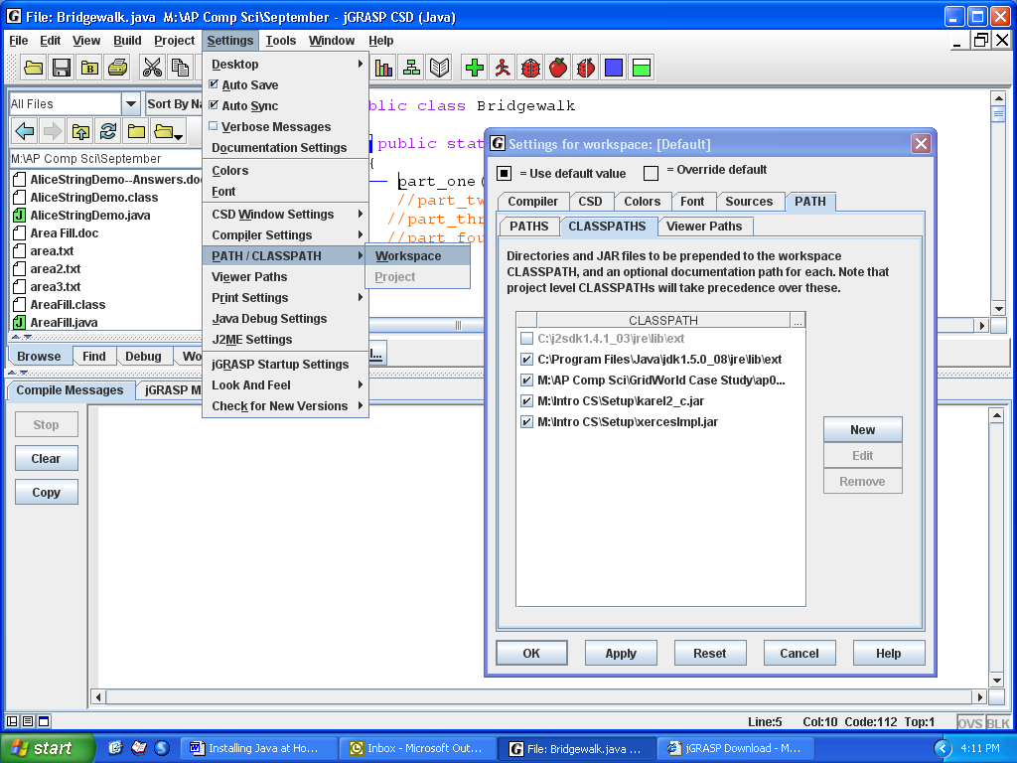
1

9. Run the JKarel program. If something doesn’t work, make note of any error messages and bring them to your teacher.
3
4
2
6

- Turn on your virus protection software.

- See if you can access your Java code on the school's M:/ drive through TJ's Intranet's Filecenter → View all Windows files.

